ER Model of GYB

Login GYB
- Check domain
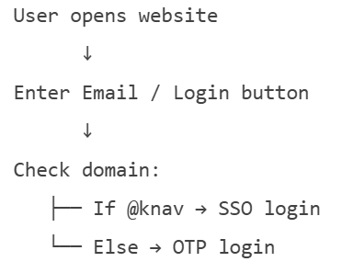

Admins list will be stored in the database, so only those people can log in and access the admin panel.
The admin will create a list of participants using their email IDs, and this list will be saved in the database. When participants log in, the app will check if their email ID is in the list. If yes, they can continue.

